**Jenkins Master/Slave Setup**

In this article we will learn how to setup Devops tool Jenkins in master/slave mode.

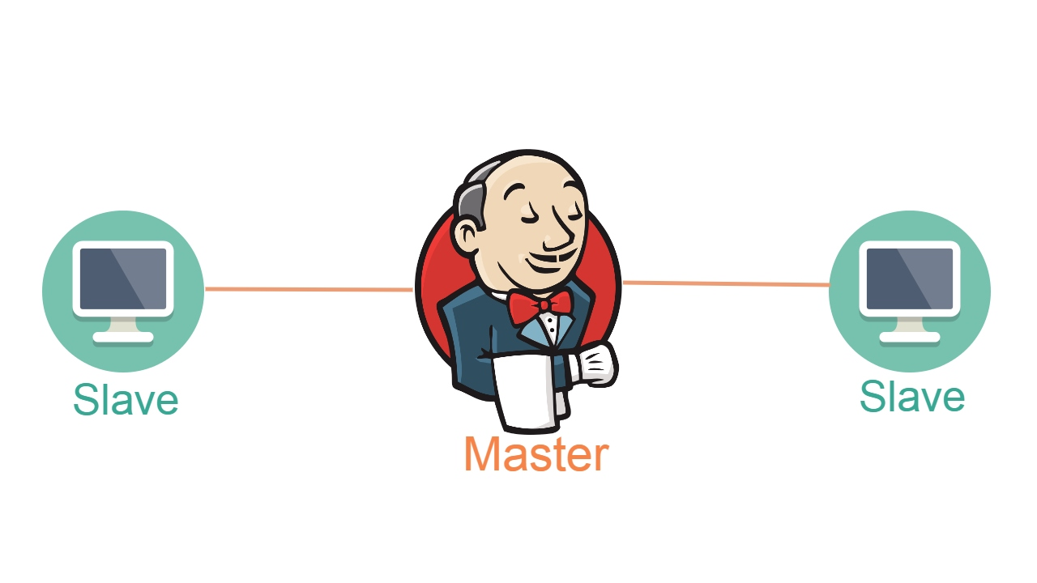

##### **Prerequisites**

Launch an EC2 Linux instance to host Jenkins. Make sure to add Custom TCP port: 8080 in AWS Security Groups inbound rule.

Master Node: t3.small/ t3.large

Slave Node: t2.micro

1. Install Jenkins on master node.
2. Install Java on master node with same version.

Step1: Go to slave node Instance.

[ec2-user@ip-172-31-85-255 ~]$ *sudo su –*

[root@ip-172-31-85-255 ~]# *adduser myslave*

[root@ip-172-31-85-255 ~]# *su – myslave*

[myslave@ip-172-31-85-255 ~]$]

Now Generate keys for this user

[myslave@ip-172-31-85-255 ~]$ *ssh-keygen -t rsa*

[myslave@ip-172-31-85-255 ~]$ *cd .ssh*

[myslave@ip-172-31-85-255 .ssh]$ ls

id_rsa id_rsa.pub

Share the public key (id_rsa.pub) to the master node then they both will communicate.

[myslave@ip-172-31-85-255 .ssh]$ *cat id_rsa.pub*

ssh-rsa  myslave@ip-172-31-85-255.ec2.internal

[myslave@ip-172-31-85-255 .ssh]$ *cat id_rsa.pub > authorized_keys*

[myslave@ip-172-31-85-255 .ssh]$ ls

authorized_keys id_rsa id_rsa.pub

[myslave@ip-172-31-85-255 .ssh]$ *cat authorized_keys*

ssh-rsa  myslave@ip-172-31-85-255.ec2.internal

[myslave@ip-172-31-85-255 .ssh]$ *chmod 700 authorized_keys*

Next go to master node

Jenkins Runs /var/lib/Jenkins there is no .ssh directory go and create .ssh directory in master node.

[root@ip-172-31-85-211 ~]# *mkdir .ssh*

drwx-------. 2 root root 29 Jul 7 15:16 .ssh

change ownership to jenkins: jenkins.

drwxr-xr-x. 2 jenkins jenkins 6 Jul 8 17:38 .ssh

[root@ip-172-31-85-211 jenkins]# *echo "ssh-rsa  myslave@ip-172-31-85-255.ec2.internal" > /var/lib/jenkins/.ssh/known_hosts*

[root@ip-172-31-85-211 .ssh]# *chown jenkins:jenkins .ssh*

[root@ip-172-31-85-211 .ssh]# *ls -la*

total 24

drwxr-xr-x. 3 jenkins jenkins 55 Jul 8 18:08 .

drwxr-xr-x. 22 jenkins jenkins 16384 Jul 8 17:52 ..

drwxr-xr-x. 2 jenkins jenkins 6 Jul 8 18:08 .ssh

-rw-r--r--. 1 root root 364 Jul 8 17:48 known_host

-rw-r--r--. 1 root root 592 Jul 8 18:03 known_hosts

[root@ip-172-31-85-211 .ssh]# chown jenkins:jenkins known_hosts

[root@ip-172-31-85-211 .ssh]# ls -la

total 24

drwxr-xr-x. 3 jenkins jenkins 55 Jul 8 18:08 .

drwxr-xr-x. 22 jenkins jenkins 16384 Jul 8 17:52 ..

drwxr-xr-x. 2 jenkins jenkins 6 Jul 8 18:08 .ssh

-rw-r--r--. 1 root root 364 Jul 8 17:48 known_host

-rw-r--r--. 1 jenkins jenkins 592 Jul 8 18:03 known_hosts

[root@ip-172-31-85-211 .ssh]# chown jenkins:jenkins known_host

[root@ip-172-31-85-211 .ssh]# ls -la

total 24

drwxr-xr-x. 3 jenkins jenkins 55 Jul 8 18:08 .

drwxr-xr-x. 22 jenkins jenkins 16384 Jul 8 17:52 ..

drwxr-xr-x. 2 jenkins jenkins 6 Jul 8 18:08 .ssh

-rw-r--r--. 1 jenkins jenkins 364 Jul 8 17:48 known_host

-rw-r--r--. 1 jenkins jenkins 592 Jul 8 18:03 known_hosts

[root@ip-172-31-85-211 .ssh]# ssh-keyscan -H 172.31.85.255 >>/var/lib/jenkins/.ssh/known_hosts

# 172.31.85.255:22 SSH-2.0-OpenSSH_8.7

# 172.31.85.255:22 SSH-2.0-OpenSSH_8.7

# 172.31.85.255:22 SSH-2.0-OpenSSH_8.7

# 172.31.85.255:22 SSH-2.0-OpenSSH_8.7

# 172.31.85.255:22 SSH-2.0-OpenSSH_8.7